Tale of the Orb
Game Manual
Controls | Cheats | Game Screen

Controls

‘z’ key – Select characters and options, progress through dialogue
‘x’ key – Cancel
←↑→↓ keys – Move characters, go through options
Return key – Start button

Cheats

‘o’ key – Skip scene

Game Screen

Dialogue

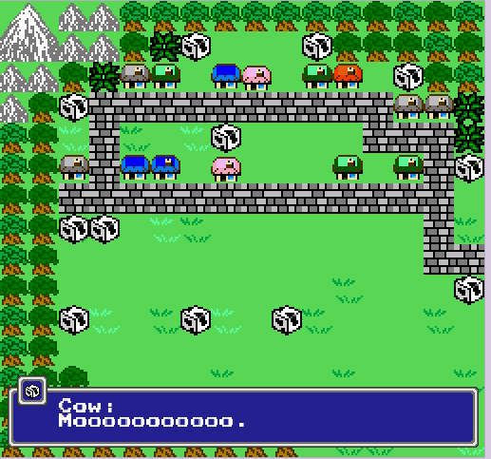

Dialogue is displayed at the bottom of the screen with an image of the speaker in the upper left corner of the dialogue box and the name to the right of it. In order to progress through the dialogue and the story, press the ‘z’ key.

Battle Interface

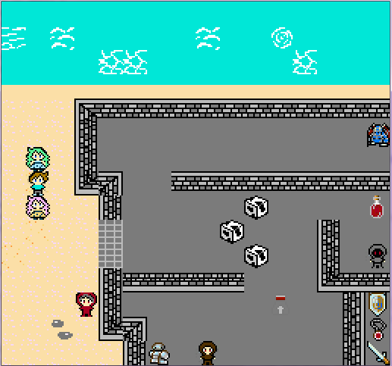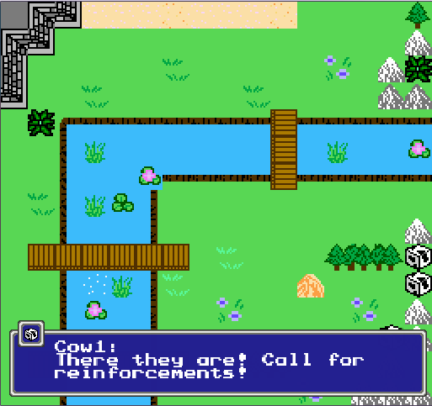
Screenshots: Example battle fields

The battle system is turned-based.

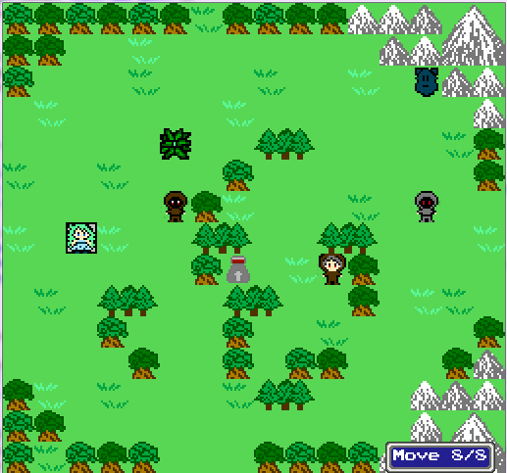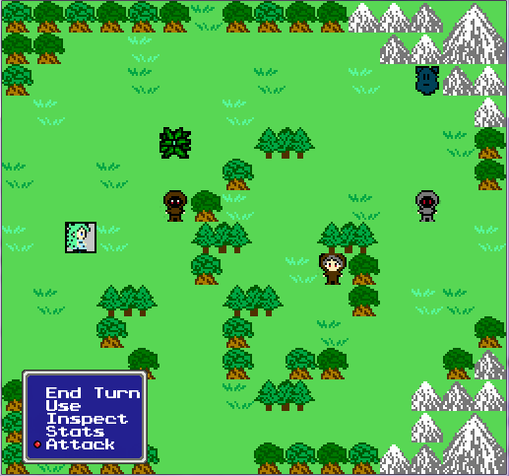

When it’s the player’s turn, in order to move, select the character that you want to move and direct it where you want them to go. In the bottom right corner of the screen during the move phase of a character, the number of remaining moves is displayed (as shown on the left). Once you have decided where you want to place that character, press ‘z’ again and a battle command menu will pop up on the bottom left corner of the screen (as shown on the right).

End Turn – End that character’s turn
Use – Use an adjacent item/object
Inspect – Inspect an adjacent item/object
Stats – Display that character’s stats
Attack – Attack a nearby enemy

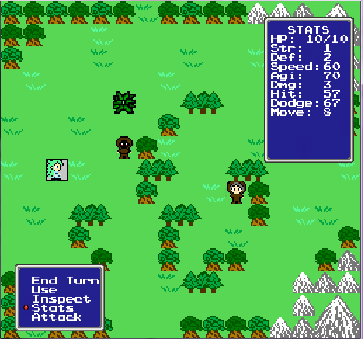

If you click on an empty square, an option called End Turn will appear, allowing you to completely end your turn without having to give commands to each character.

Once the map has been cleared of all monsters, the game will progress.

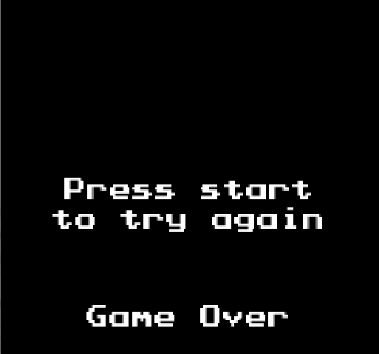

If all of your characters are slain in battle, the game ends.

